[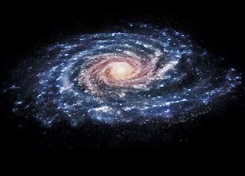](https://www.bing.com/images/search?view=detailV2&ccid=tITsgVxr&id=489EF0141673A61E84809942C98586B261DD9CC6&thid=OIP.tITsgVxr_pDcZK9uDNb5DAHaEo&mediaurl=https%3a%2f%2fth.bing.com%2fth%2fid%2fRb484ec815c6bfe90dc64af6e0cd6f90c%3frik%3dxpzdYbKGhclCmQ%26riu%3dhttp%253a%252f%252fastronomy.com%252f%257e%252fmedia%252fD769AE120E284A8BA9C26B02BCF7FDE5.jpg%26ehk%3dKseQGG9aJUJ2zWUQJr5mGR2x7H10Mdr9MLGMz4MmD0o%253d%26risl%3d%26pid%3dImgRaw&exph=641&expw=1024&q=droga+mleczna+obrazek&simid=608009391706936268&ck=2655DDD57CCC2F81F356A354390B791B&selectedIndex=24&FORM=IRPRST)

DROGA MLECZNA